
FULL CYCLE SAP MM IMPLEMENTATION
SAP IMPLEMENTATION

May 5, 2026
BGMI PVT LTD
INDORE

PROJECT NAME -SAP IMPLEMENTATION PROJECT (ENTERPRISE STRUCTURE -BGMI)
PREPARED BY – KARN PRATAP SINGH RATHORE
MODULE – SAP MATERIALS MANAGEMENT & FI INTEGRATION

- INTRODUCTION,
The objective of this project is to configure an end-to-end Enterprise Structure in SAP S/4HANA for BGMI LTD, covering the complete lifecycle from Procurement to Invoice Verification.

- ENTERPRISE STRUCTURE;
COMPANY CODE – BGMI PVT LTD (BASED IN INDORE) T-CODE OX02
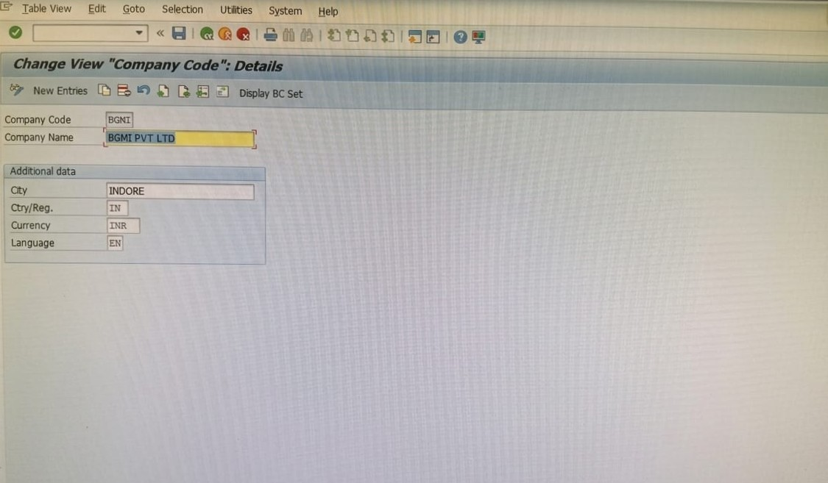

- PLANT CODE – DEFINED PLANT BGMI FOR MANUFACTURING AND INVENTORY MANAGEMENT T-CODE (OX10)

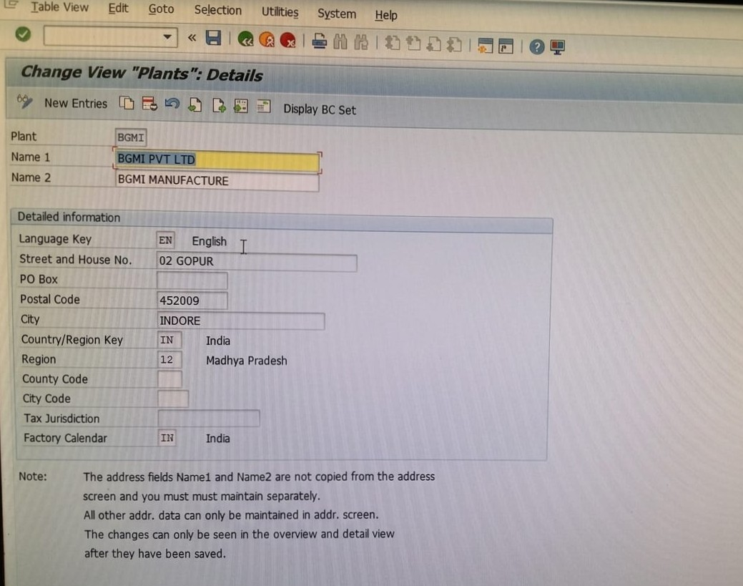

- STORAGE LOCATION- CONFIGURED STORAGE LOCATION BGMI (BGMI PVT LTD) BASED IN INDORE

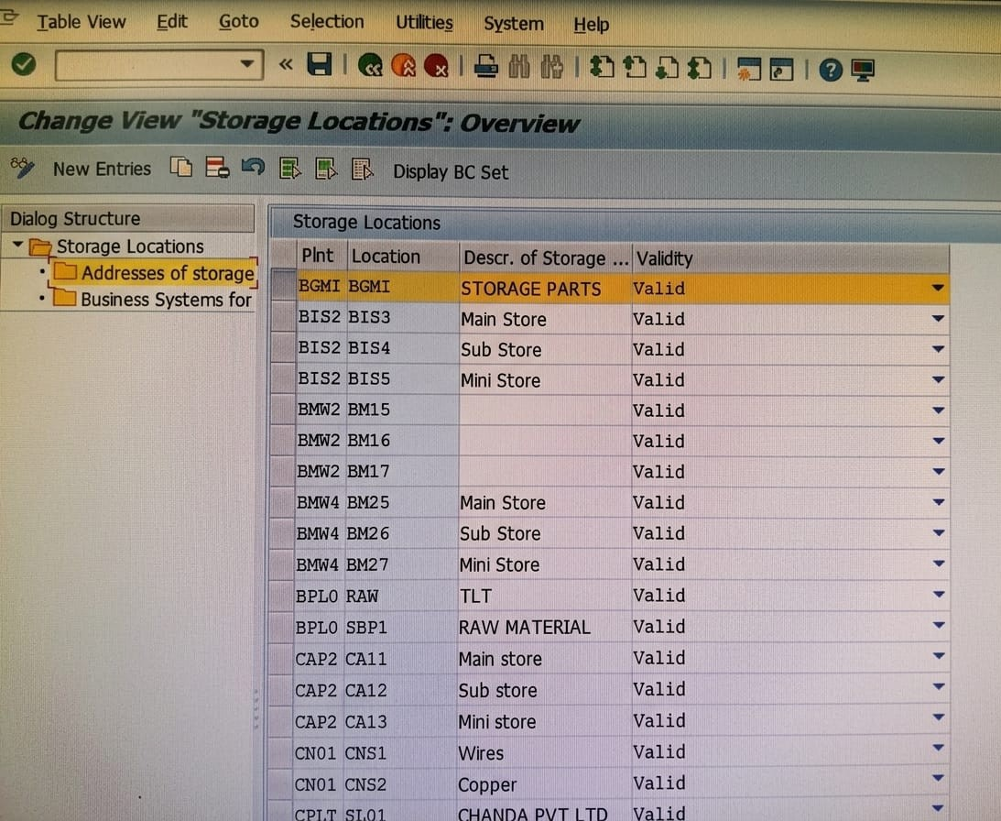

- PURCHASE ORGANIZATION – SETUP PURCHASING ORGANIZATION BGMI TO HANDEL PROCUREMENT ACTIVITIES
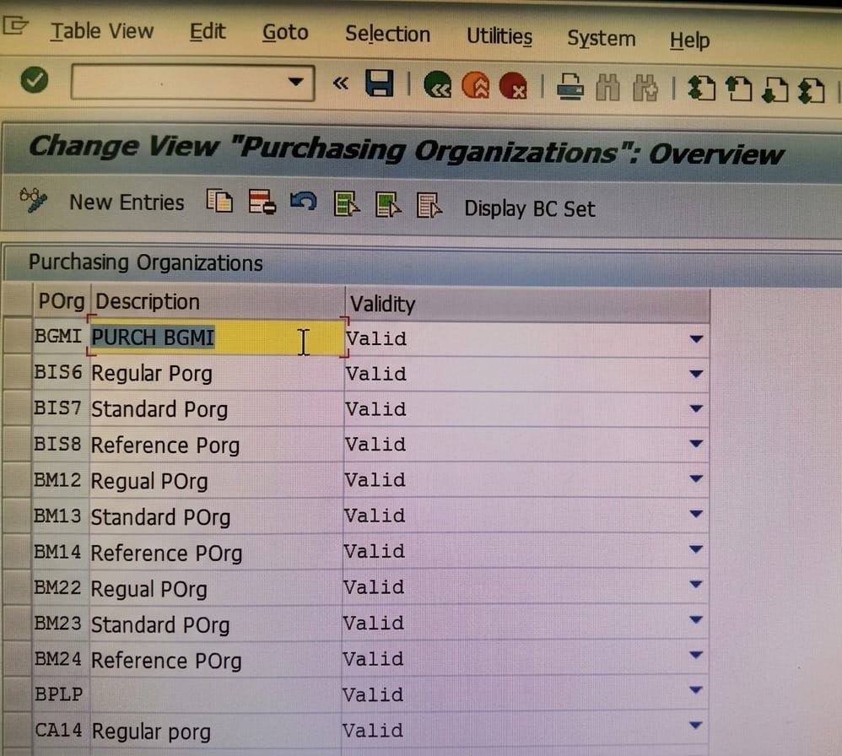
- ASSIGNMENT OF PURSCHASE ORG TO CO CODE- This configuration step involves linking the Purchasing Organization 'BGMI' to the Company Code 'BGMI'. This assignment is a critical integration point between the Materials Management (MM) and Financial Accounting (FI) modules. It ensures that all procurement transactions (like Invoice Verification) are automatically posted to the correct legal entity's financial books

- MASTER DATA IMPLEMENTATION T-CODE(OMS2)
Material Type (BGMI) It determines the fundamental attributes of a material, such as which User Departments (Views) are maintained and whether the material is produced internally or procured externally.

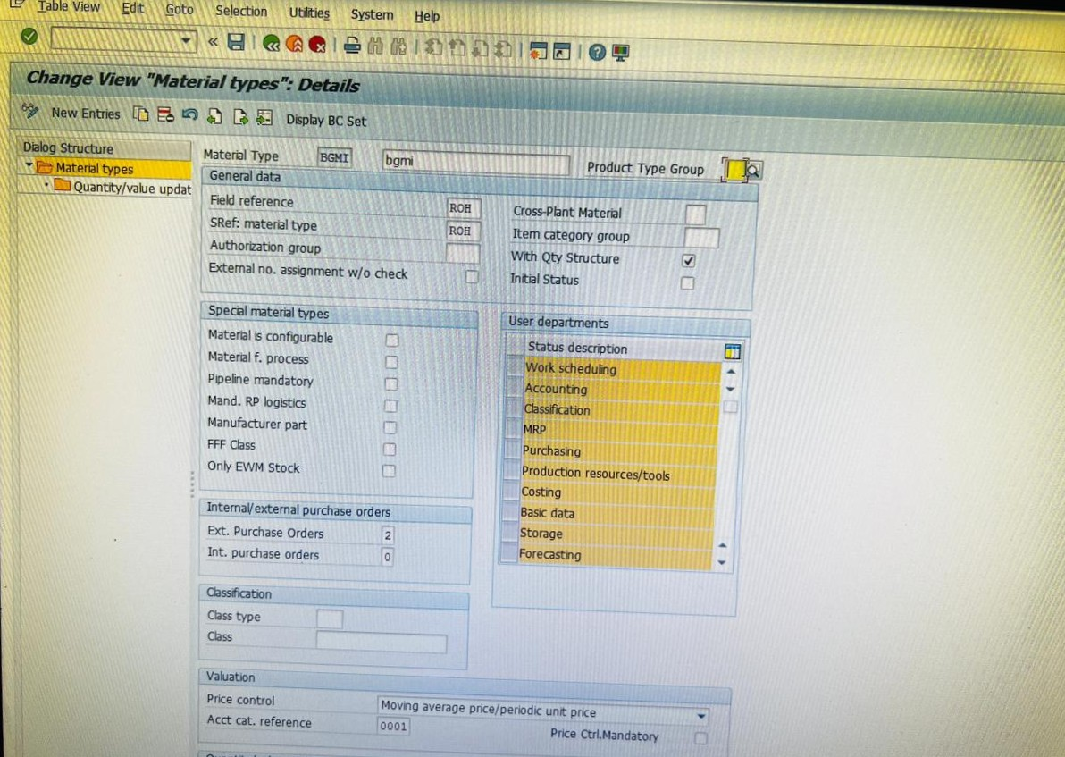

MATERIAL GROUP T-CODE (OMSF) - It is used to group several materials with similar characteristics for reporting and analysis purposes, making it easier to manage purchasing and inventory tracking.
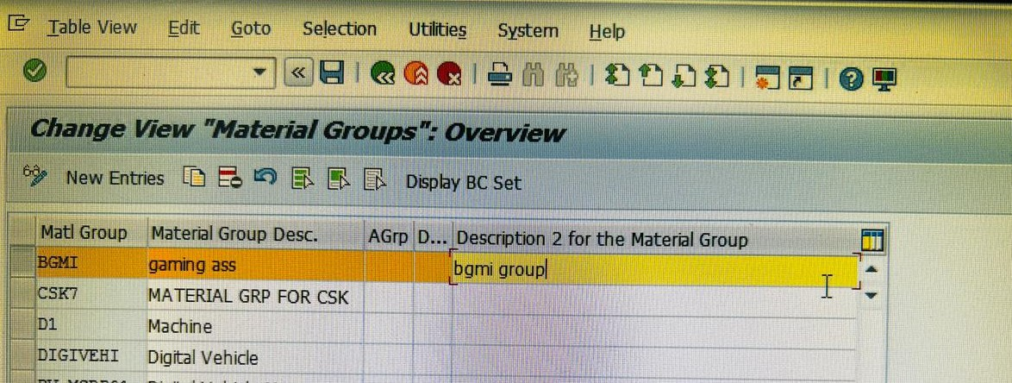

MATERIAL GROUP (BGMI)

NUMBER RANGE T-CODE (MMNR) -​It defines the specific numeric intervals assigned to a material type, ensuring every material created has a unique identification number within the SAP system.
MATERIAL GROUP- BGMI & NUMBER RANGE IS B1
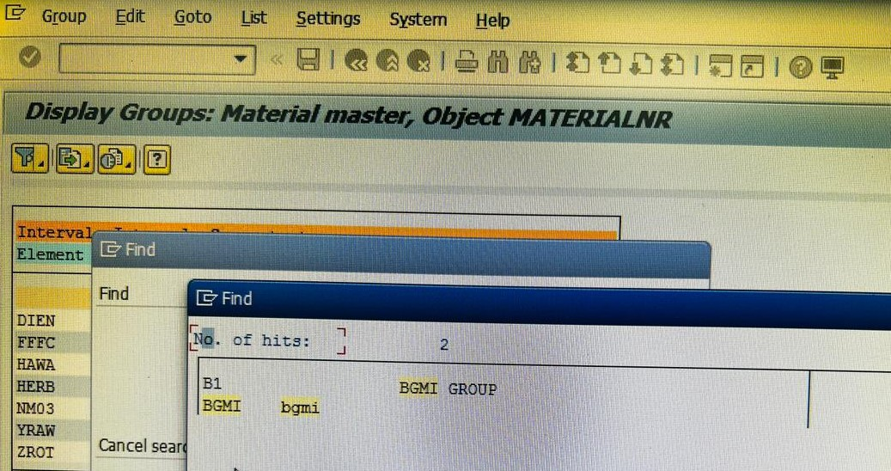
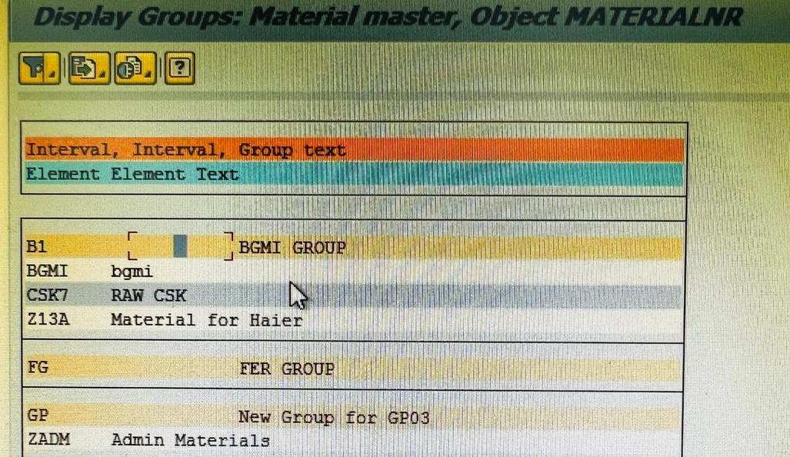

- CREATE MATERIAL MASTER (MM01)
It is the core transaction used to create a new material by integrating data from various departments like Purchasing, Accounting, and MRP. It uses the pre-defined Material Type and Group to establish how the material will be managed and valued in the system

MATERIAL CREATED (3017 – BGMI RAW MATERIAL IN PLANT BGMI)

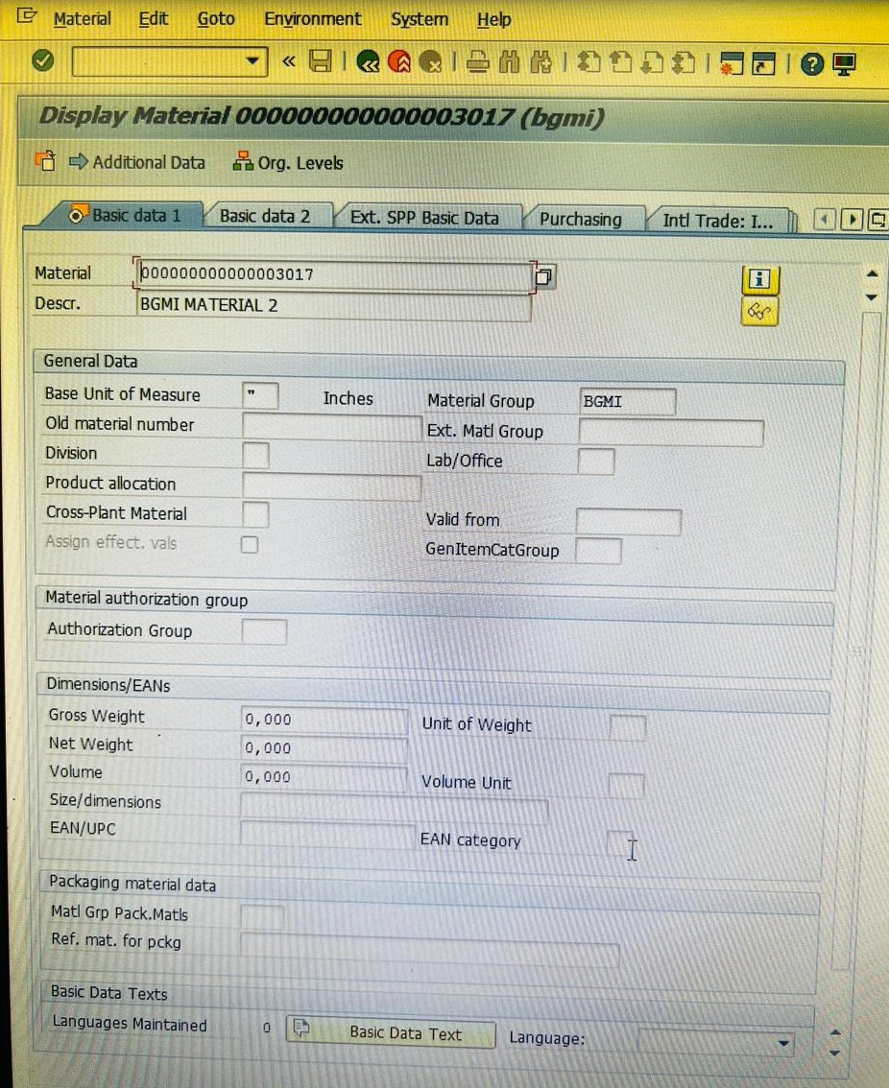

- BP CONFIGURATIOIN IN BGMI PVT LTD

VENDOR ACCOUNT GROUP - It specifies the unique numeric interval assigned to the Vendor Account Group to identify the supplier in the Financial Accounting (FI) module.

VENDOR ACC GROUP – BGMI (BGMI IMPORT)

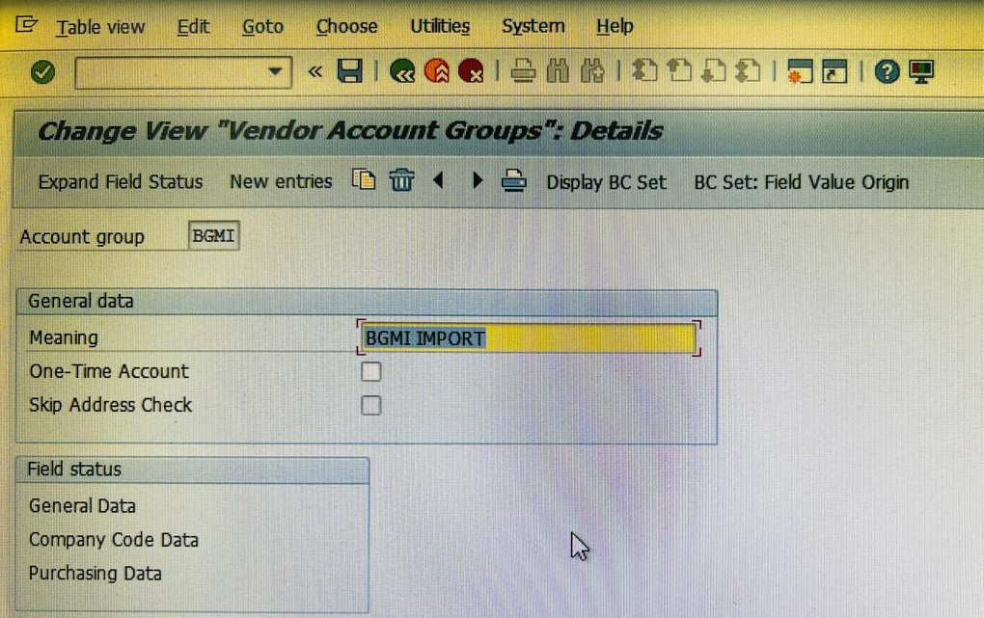

NUMBER RANGE FOR VENDOR ACC GROUP IN BGMI PVT LTD BASED IN INDORE

NUMBER RANGE - It specifies the unique numeric interval assigned to the Vendor Account Group to identify the supplier in the Financial Accounting (FI) module.
NUMBER RANGE (BG) IS CREATED FOR VENDOR ACC GROUP BGMI

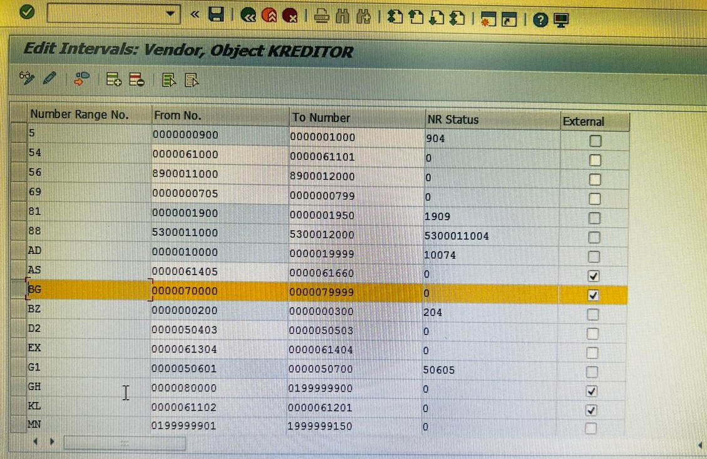

DEFINE BP ROLE (BUSINESS PARTNER) - BP Roles (like FLVN00 for Financials or FLVN01 for Purchasing) determine which specific business data can be maintained for a partner.

BP ROLE DEFINED IN BGMI PVT LTD BASED IN INDORE

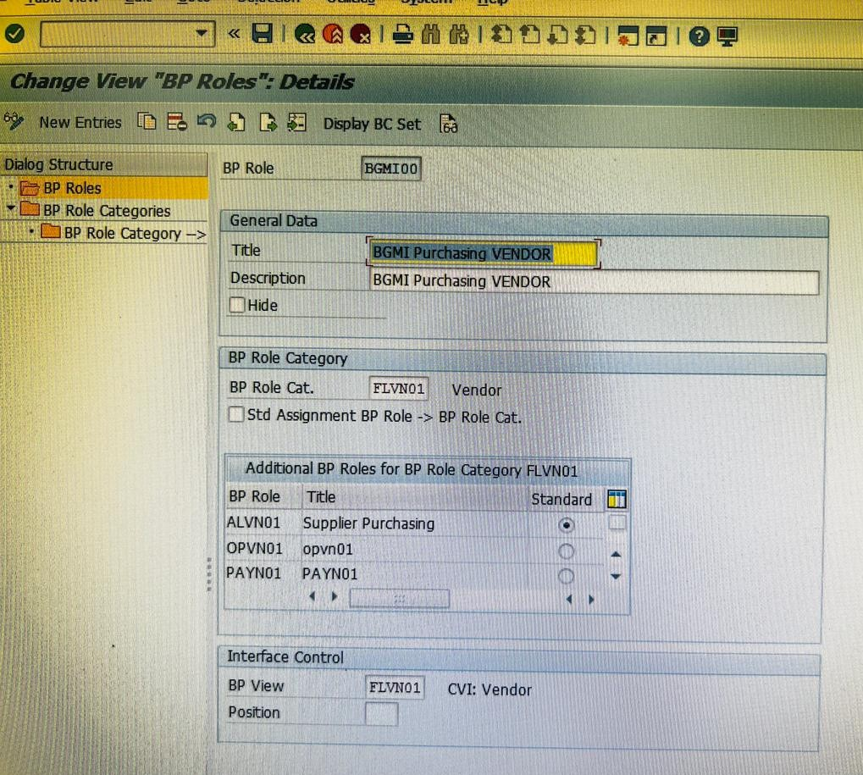

BP NUMBER RANGE - This defines the independent numeric interval for the Business Partner entity, which can be kept the same as the Vendor number for consistency.

BP NUMBER RANGE (BG)CREATED IN BGMI PVT LTD BASED IN INDORE

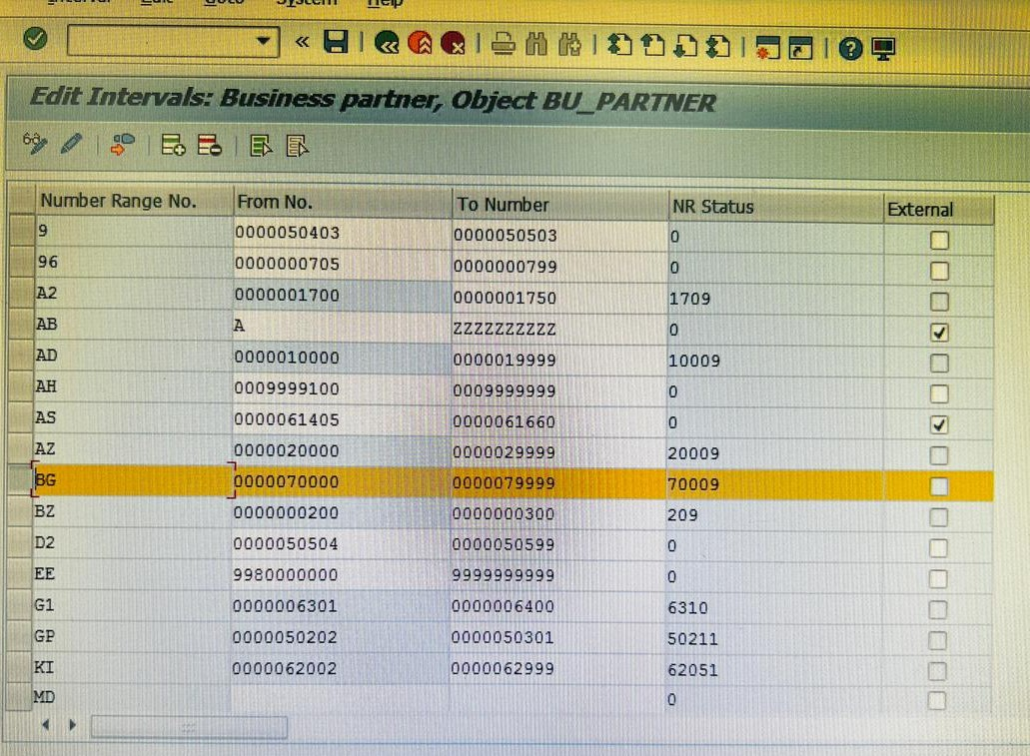

MASTER DATA SYNCHRONIZATION - Known as Customer Vendor Integration, this critical step links the BP Number Range with the Vendor Number Range to ensure both are created simultaneously

MASTER DATA SYNCHRONIZATION IS DONE IN BGMI PVT LTD BASED IN INDORE
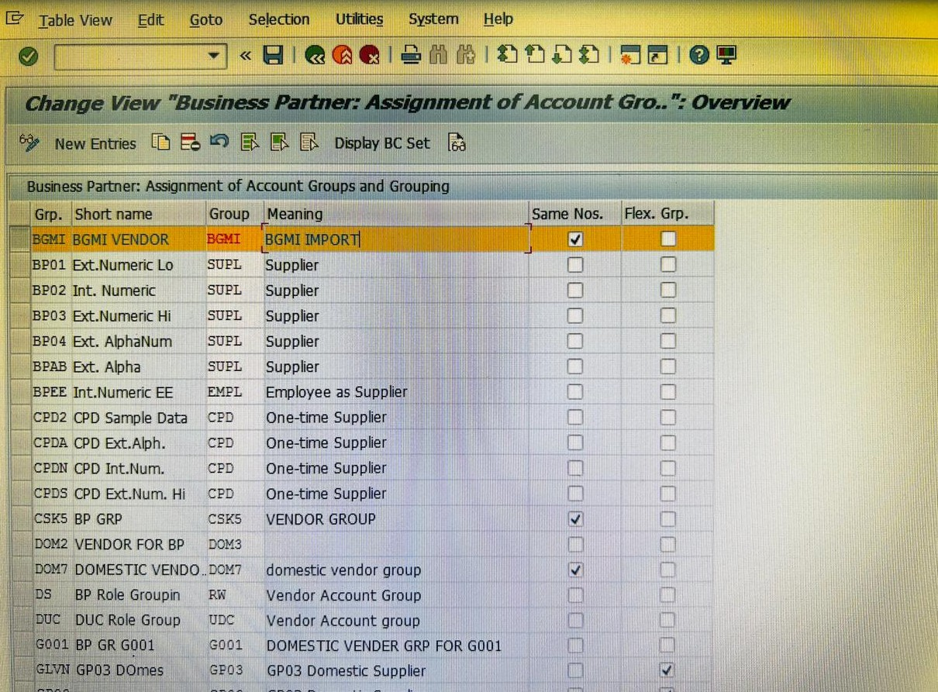
CREATE BUSINESS PARTNER (BP) - This is the final execution step where the Business Partner is actually created in the system, automatically generating the linked Vendor master data.
BUSINESS PARTNER 70000 IS CREATE IN BGMI PVT LTD BASED IN INDORE
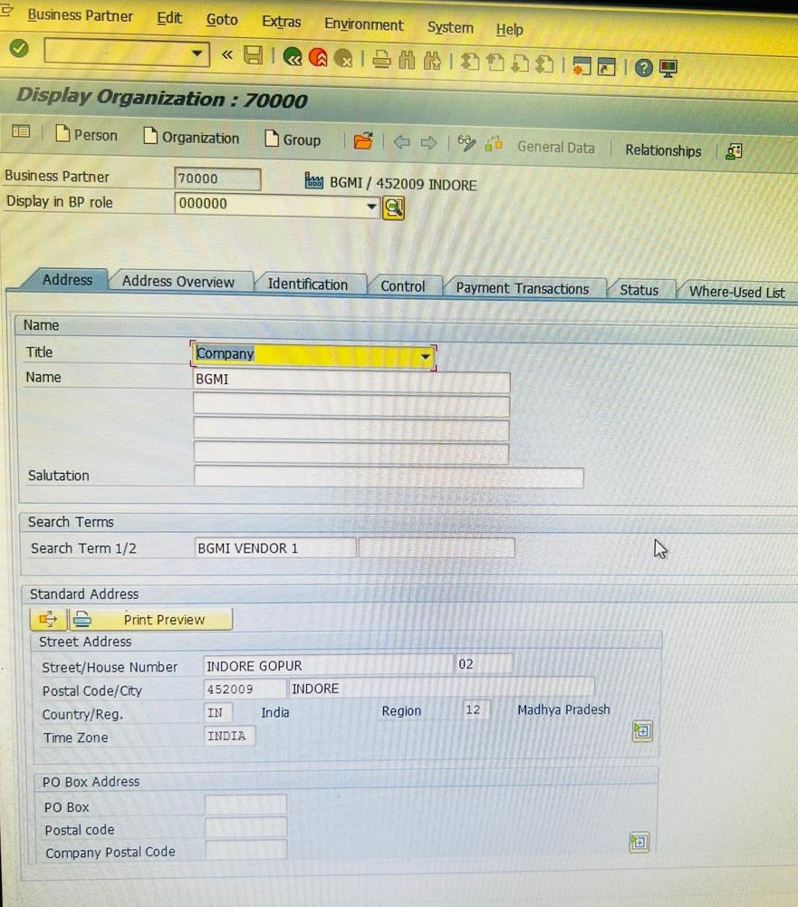
BP CONFIGURATION IS COMPLETRED IN CO CODE BGMI

FI-MM (FINANCIAL INTEGRATION)
General Ledger (G/L) Account Creation
It is a master data record used to record all financial transactions in the General Ledger, ensuring proper Financial Integration with procurement activities. In this project, G/L 400006 is configured to track the costs associated with material movements and accounting entries.
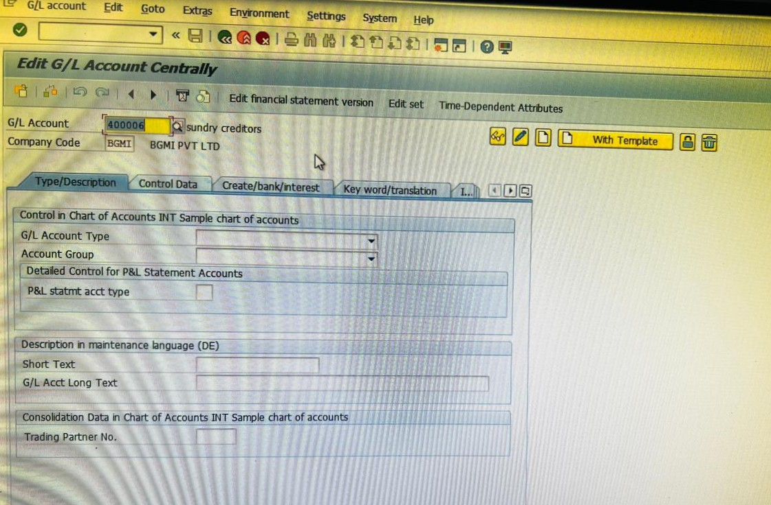

CHART OF ACCOUNTS (INT) - The foundation of the project begins with linking Material Management movements to the General Ledger (G/L) accounts. This ensures that every procurement transaction reflects accurately in the financial statements.
Chart of Accounts (INT): Used as the operational Chart of Accounts to define the structure of G/L accounts
CHART OF ACCOUNT (INT) ASSIGNED IN BGMI PVT LTD BASED IN INDORE

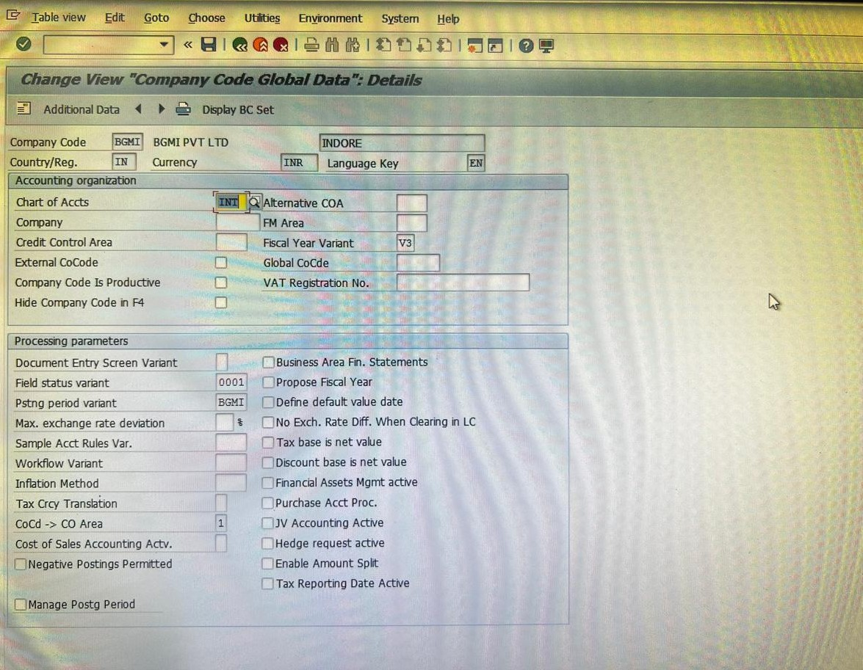

Key Transaction Groupings:
BSX (Inventory Postings): Configured to determine the Inventory Asset account that is debited or credited during goods movements.
WRX (GR/IR Clearing): Established as the clearing account to manage the timing difference between Goods Receipt and Invoice Receipt

IN TRANSACTION WRX AND BSX GL ACC 400006 IS MAINTAINED ALONG WITH VALUATION CLASS
MAINTAINED IN BGMI PVT LTD BASED IN INDORE
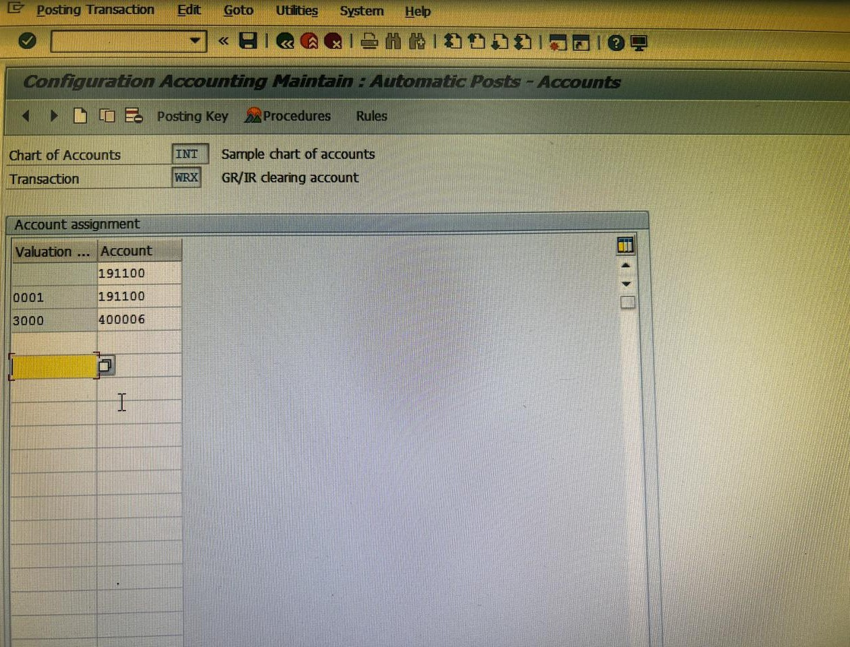

TAX KEYS – JIC, JIS, JII
These transaction keys are used for Input Tax Determination to ensure tax credits are posted to the correct accounts:
JIC (Central Input Tax): Maps the G/L account for Central Tax (e.g., CGST) input credits.
JII (Integrated Input Tax): Maps the G/L account for Integrated/Inter-state Tax (e.g., IGST) when dealing with out-of-state vendors.
JIS (State Input Tax): Maps the G/L account for State Tax (e.g., SGST) input credits.
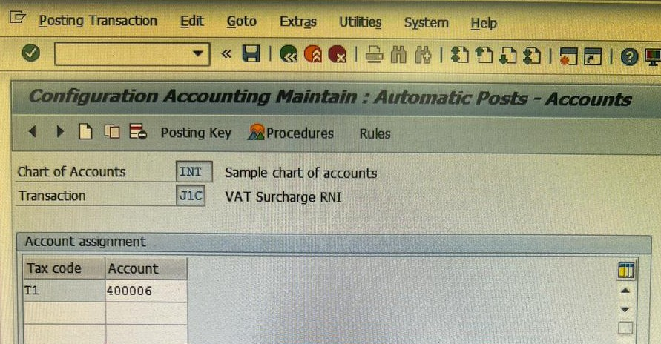
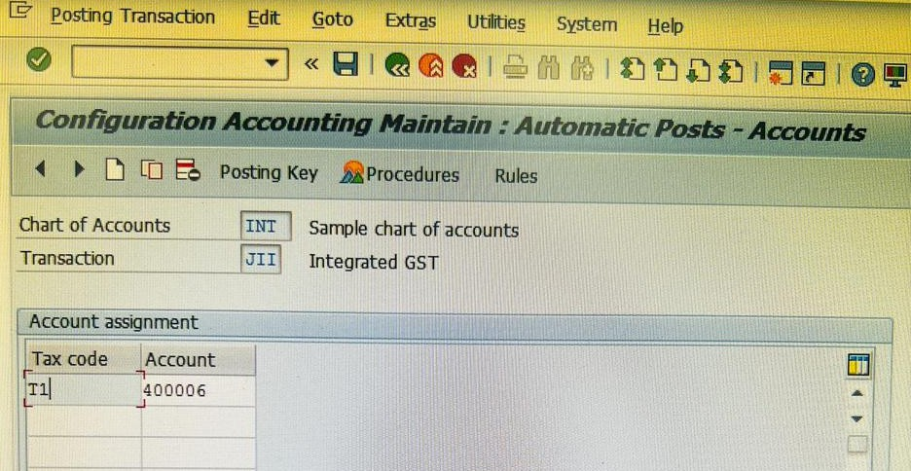
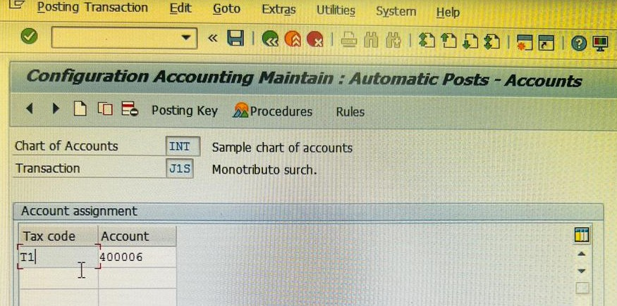
THESE ARE THE TRANSACTION KEYS AND I HAVE MAINTAINED MY GL ACCOUNT IN THESE KEYS

PRICING ARCHITECTURE & LOGIC- The pricing strategy is built using a bottom-up approach, moving from specific data tables to a global calculation logic.

CONDITION TABLE - This table serves as the database for storing condition records. It defines the combination of fields (e.g., Vendor/Material) that the system uses to search for a valid price
888 CONDITION TABLE IS CREATED IN BGMI PVT LTD
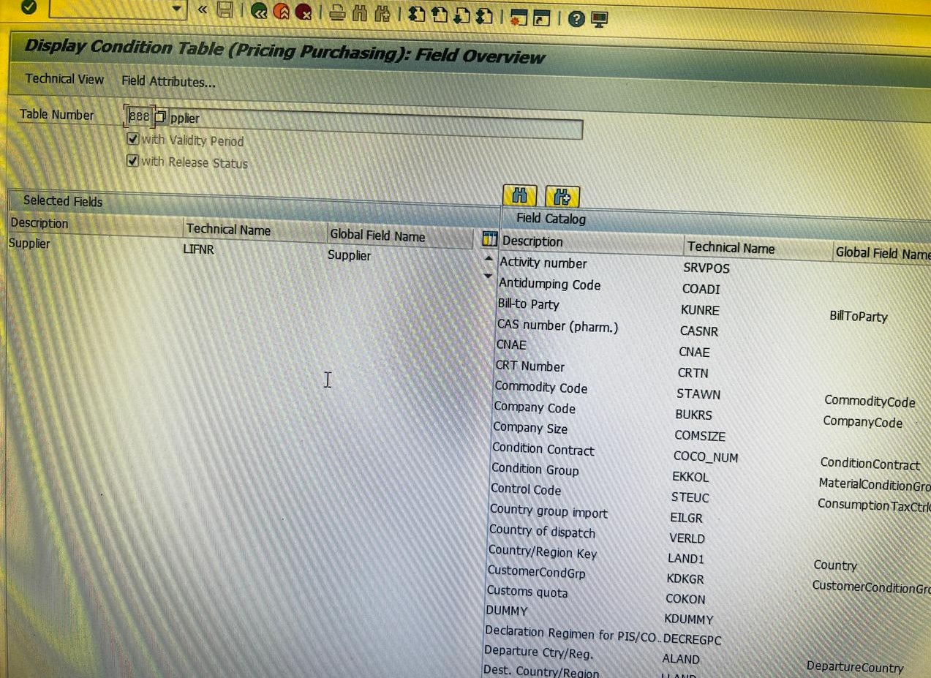

Access Sequence (Z888)
A search strategy assigned to condition types. It tells the system the specific order in which to search the Condition Tables (starting with Table 888) to find a valid price or discount.
Z888 ACCESS SEQUENCE IS CREATED
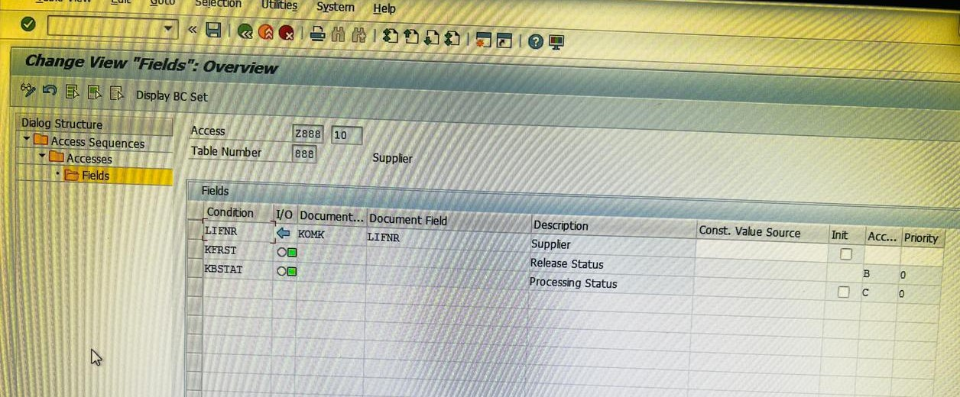
Condition Types (ZBG1 & PBXX)
PBXX (Gross Price): The standard SAP condition type used for manual price entry in a Purchase Order.
ZBG1 (Custom Condition): A specialized condition type created for this project to handle specific price components, such as surcharges or project-specific adjustments.
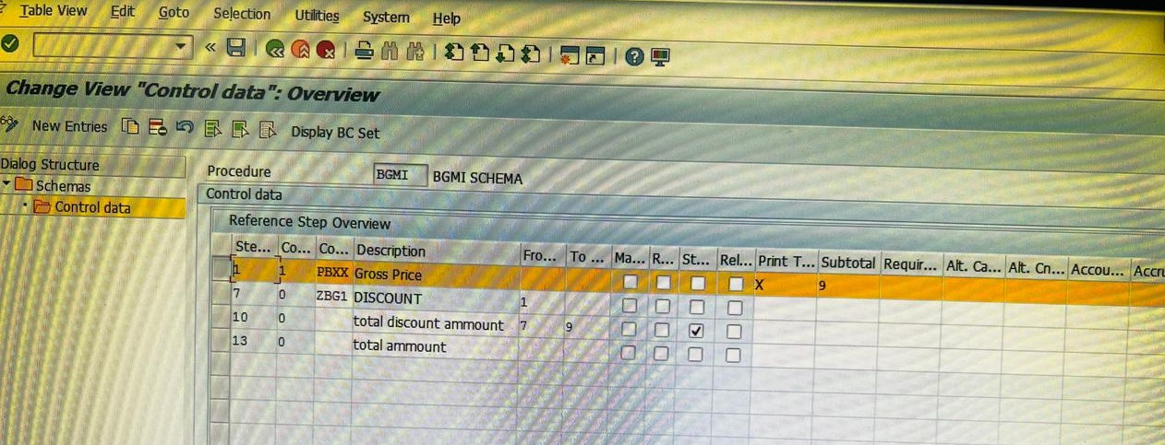
CALCULATION SCHEMA CONTROL
The master pricing procedure that groups all condition types. It defines the calculation sequence, step numbers, and how the net and effective prices are derived.
SEE IN CONTROL DATA OF SCHEMA CONDITIONS ARE MAINTAINED

Schema Group Vendor (B1)
​The link between the vendor master and the pricing procedure. By assigning Schema Group B1 to the Vendor, the system is instructed to automatically trigger the BGMI Schema whenever a Purchase Order is created for that vendor.
SCHEMA GROUP B1 IS ASSIGNED IN VENDOR ACCOUNT (70000)
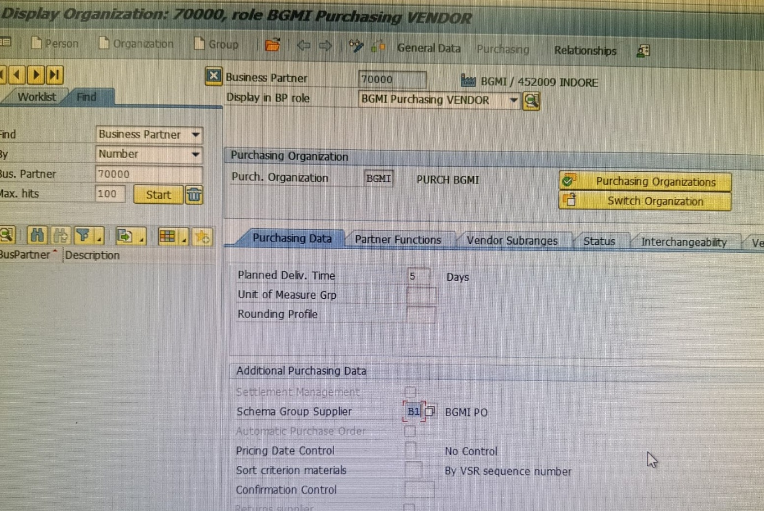

- OVERHEAD MANAGEMENT & CONTROLLING (CO) CONFIGURATION

After setting up the financial and procurement foundation, the next critical phase was the integration of Controlling (CO) to monitor and manage internal costs.
1. Establishment of Controlling Area: BGMI
The Controlling Area (BGMI) serves as the highest organizational unit in Management Accounting. It allows for the tracking of costs and revenues across the procurement cycle.
Header Name: Configuration of Controlling Area "BGMI"
Definition:
"The Controlling Area BGMI was established to provide a centralized framework for cost accounting. It is mapped to the Chart of Accounts (INT) and the respective Company Code to ensure a seamless flow of data between MM (Materials Management) and FI (Financial Accounting). This configuration enables the system to capture price variances and consumption costs during the procurement process

CO AREA (BGMI) WAS CREATED AND ASSIGNED IN BGMI PVT LTD COMPANY CODE (BGMI) BASED IN INDORE

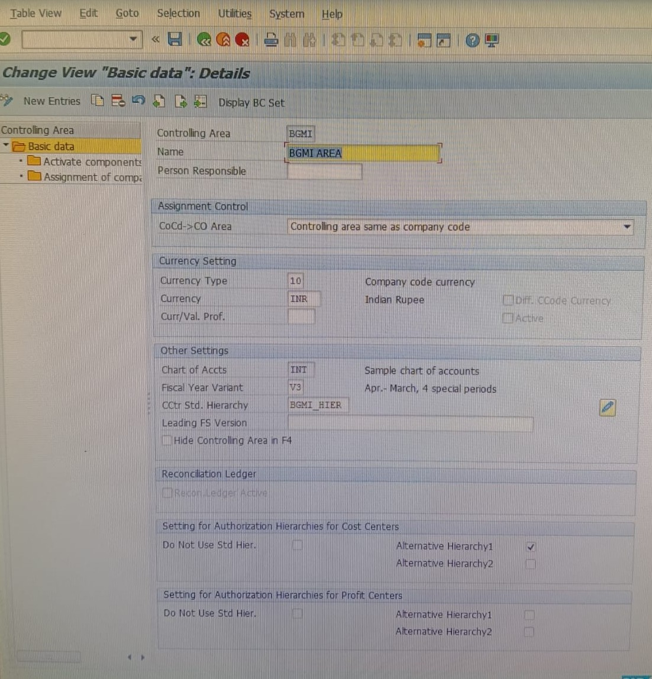
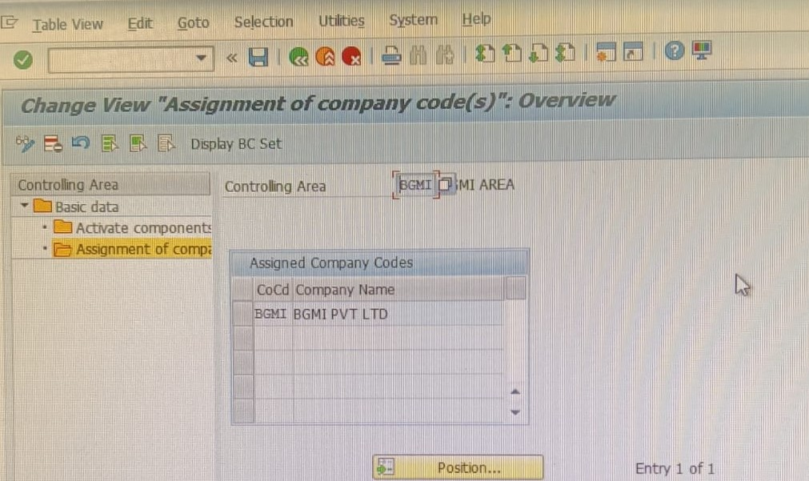
ASSIGNMENT OF BGMI CO AREA TO COMPANY CODE BGMI

Cost Centre Master Data: BGMI
To accurately track where the money is being spent during material procurement (such as consumption or departmental expenses), a specific Cost Centre was created.
Header Name: Cost Centre Implementation: BGMI
Definition:
"A dedicated Cost Centre, BGMI, was created to serve as a departmental unit where costs are collected and monitored. In this implementation, the Cost Centre is utilized during Goods Issues (MIGO) and Service Procurements to ensure that every material consumption is accounted for under the correct cost object. This facilitates precise budget tracking and overhead management."
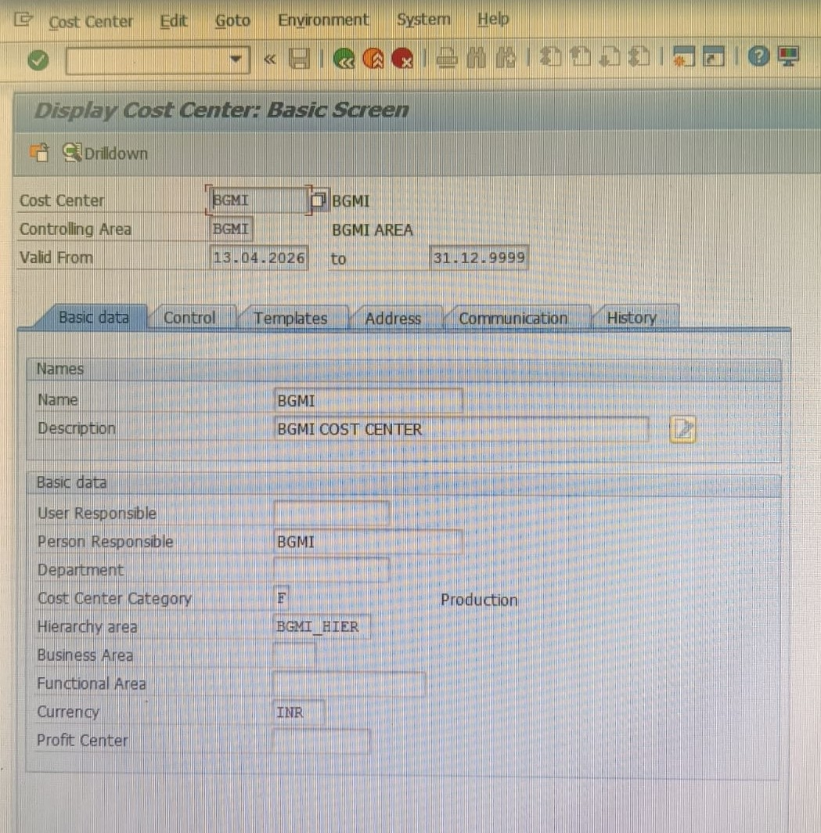
Integration Summary for Project Report:
By defining the Controlling Area BGMI and Cost Centre BGMI, the project ensures that whenever a material is procured or consumed, the financial impact is not only recorded in the G/L (via OBYC) but also tracked within the specific department (CO). This creates a "Full-Loop Integration" between Procurement, Finance, and Management Accounting

SERVICE MASTER DATA MAINTAINED IN BGMI PVT LTD
1. Introduction
The Service Master (AC03) is a master data record in SAP Materials Management (MM) used to store descriptions of intangible activities or services (e.g., Maintenance, Consultation, Cleaning). Unlike physical materials, services are procured using the Item Category 'D' and are tracked through Service Entry Sheets (SES).
2. Backend Configuration (SPRO)
To prevent errors such as "Service Number does not exist" during procurement, the following configuration steps were performed in the Implementation Guide (IMG).
2.1 Define Service Categories
Path: SPRO > Materials Management > External Services Management > Service Master > Define Service Categories
Action: Created a new Service Category named 'BGMI'.
Settings:
Org. Status: Set to AS03 (Basic Data + MM). This ensures that all Purchasing and Accounting fields are visible in the Service Master.
Aref (Account Reference): Set to 0006 (Reference for Services). This links the category to OBYC for automatic G/L account determination
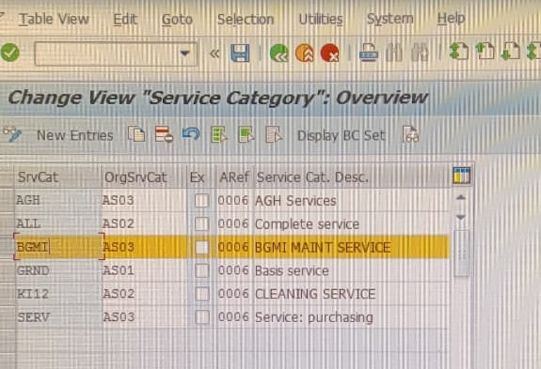
2.2 Define and Assign Number Ranges
Path: SPRO > Materials Management > External Services Management > Service Master > Define Number Ranges
Action: 1. Verified that Number Range '06' is set as Internal (meaning the system generates the number automatically).
2. Used the 'Maintain Groups' function to move the 'BGMI' category from the "Non-assigned" list into the group containing Range '06'.

NUMBER RANGE 06 ASSIGNED TO GROUP BGMI SERVIVE

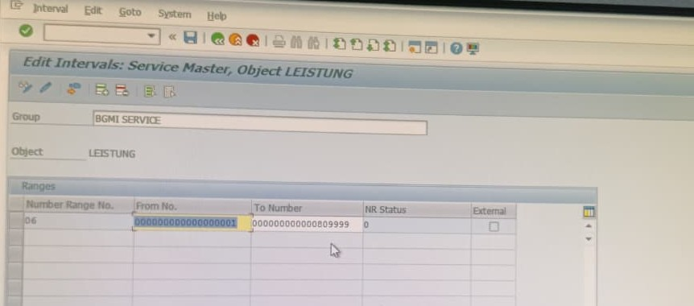
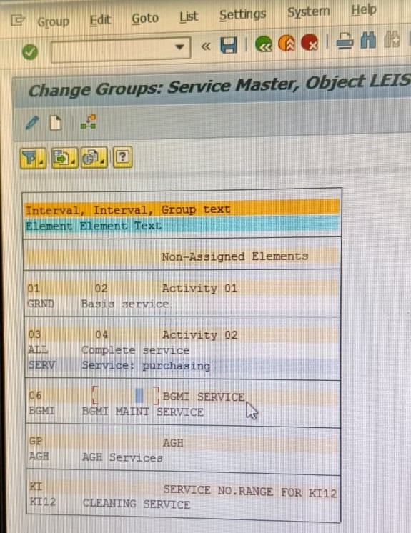
BGMI SERVICE CATEGORY WAS ASSIGNED IN BGMI SERVICE GROUP

3. Master Data Creation (Transaction: AC03)

After completing the backend setup, a specific Service Master record was created.
T-Code: AC03
Process:
Selected Create and chose Service Category 'BGMI'.
Left the Activity Number blank (System automatically assigned the next available number from range 01).
Maintained the Short Text (e.g., BGMI Annual Maintenance).
Assigned Base Unit of Measure (e.g., EA - Each).
Entered Valuation Class (e.g., 3450) to ensure the service hits the correct Expense G/L account during invoice verification.
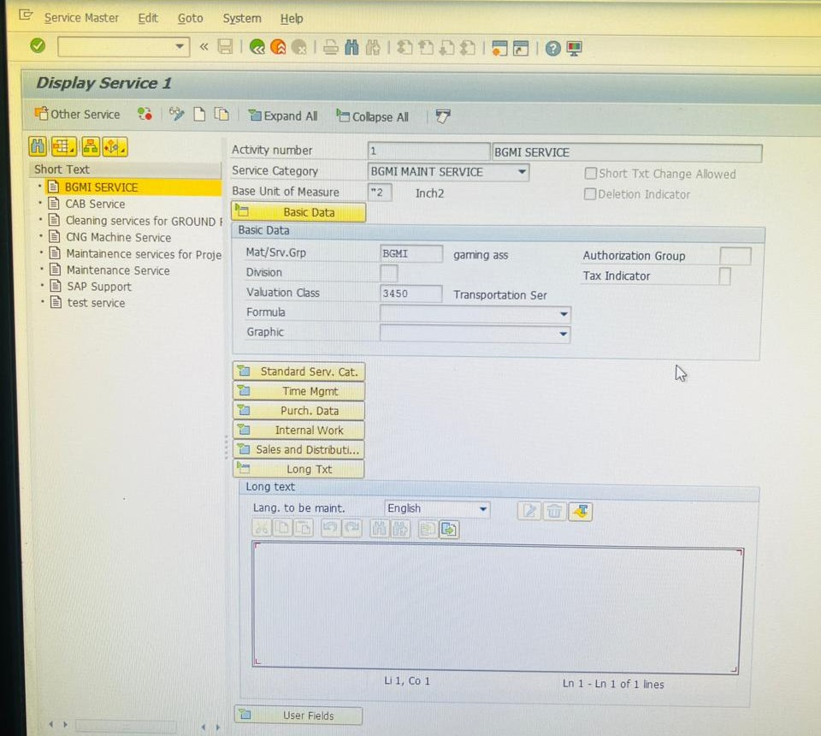
SERVICE ENTRY CREATED ACTIVITY NO IS 1

PURCHASE REQUISATION (ME51N)
This is the internal document created by a department to notify the purchasing team about the requirement of specific goods or services. It is the starting point of the procurement cycle and does not have any financial impact on the General Ledger

PR CREATED IN BGMI PVT LTD BASED IN INDORE

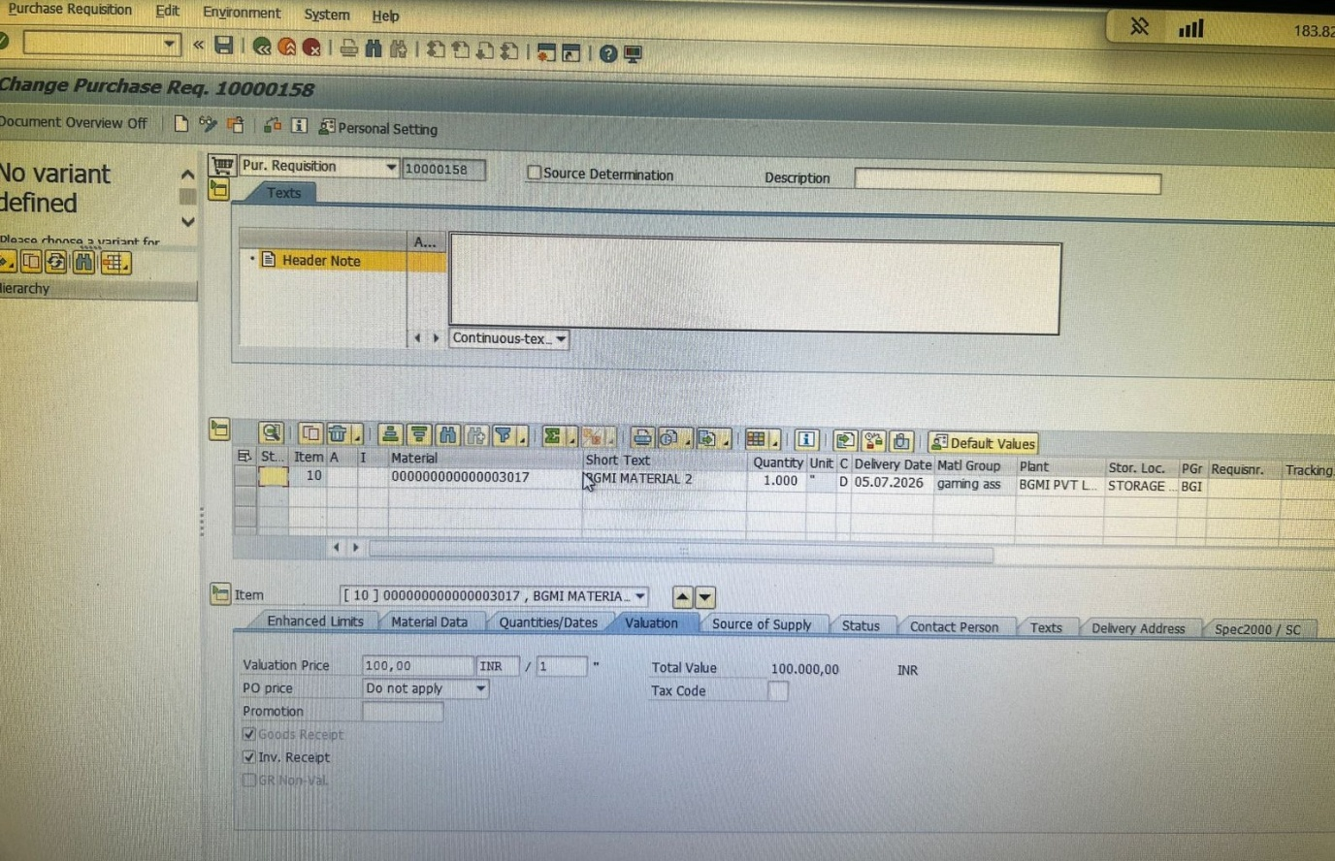

PURCHASE ORDER CREATION
The Purchase Order is a formal, legally binding contract sent to a vendor. It specifies the item details, quantity, agreed price, and delivery date. Once the PO is saved, it becomes the basis for receiving goods and processing invoices.

PURCHASE ORDER (4500000382) CREATED IN BGMI PVT LTD BASED IN INDORE
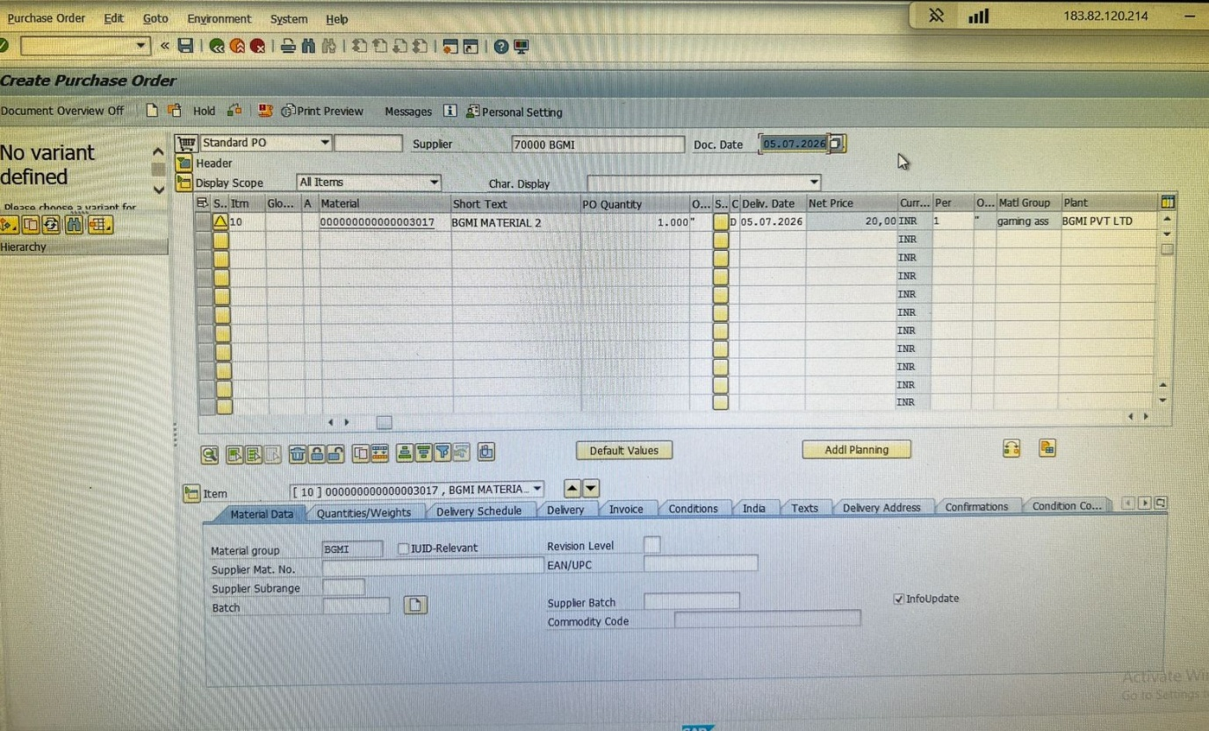

Goods Receipt (MIGO)
Definition: This step records the physical receipt of goods into the warehouse. When you perform a MIGO, the system automatically updates the inventory stock levels and creates an accounting entry.
Accounting Impact: It debits the Inventory account and credits the GR/IR (Goods Receipt/Invoice Receipt) clearing account.

MIGO GRN WAS DONE OF PURCHASE ORDER THE MATERIAL WAS RECIVED FROM VENDOR

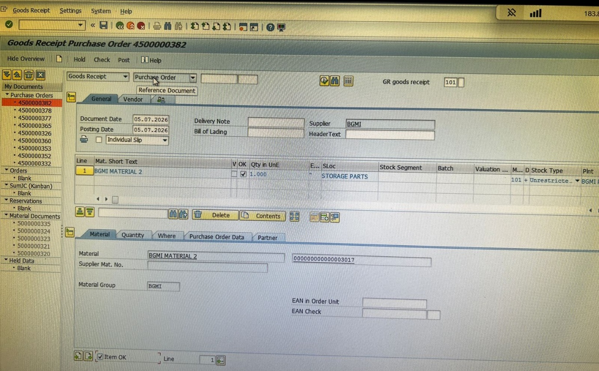
Invoice Verification (MIRO)
Definition: This is where the vendor’s invoice is entered into the system. The system matches the invoice details against the PO and the MIGO (Three-way match). This step completes the procurement side and initiates the payment process in Finance.
Accounting Impact: It debits the GR/IR account and credits the Vendor’s Payable account.

MIRO WAS DONE AFTER RECIVING OF MATERIAL BY VENDOR (70000)
PAYMEN WAS DONE AS PER INVOICE

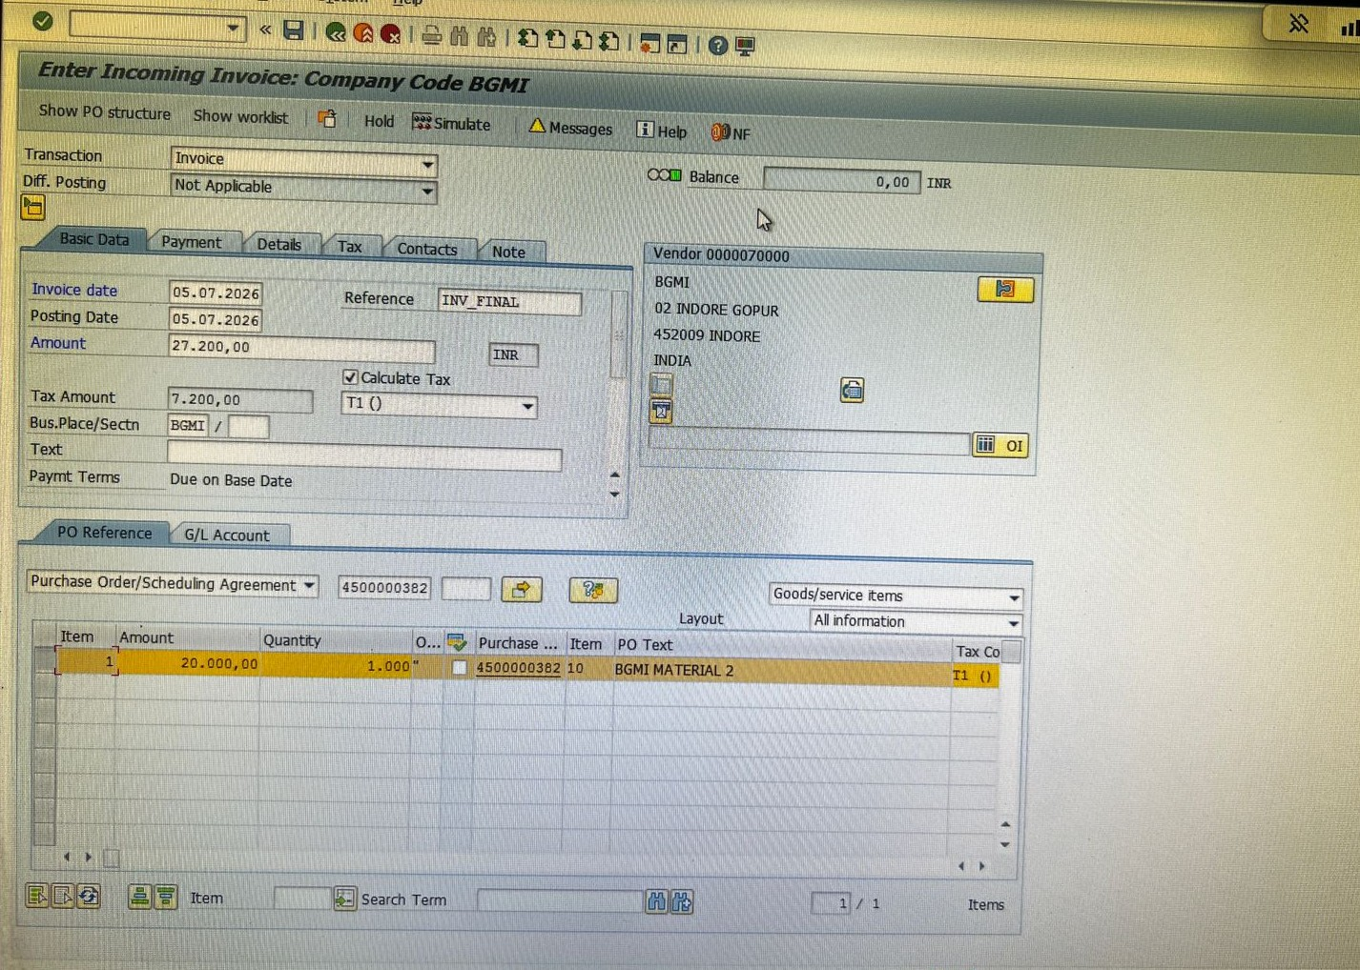
AFETR FILLING DETAILS AS PER INVOICE AND SIMULATE CHECK THE TRANSACTION
IN GL ACC DATA

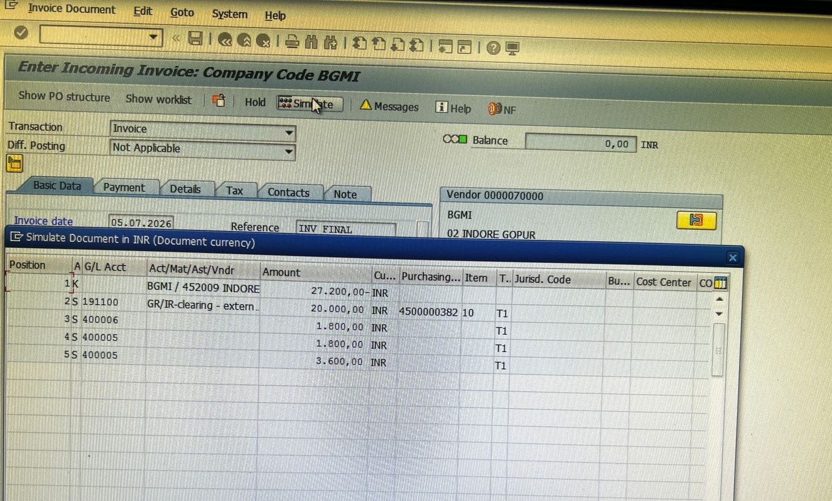
G/L Line-Item Display (FBL3N)
​Definition: This is a reporting tool used to view the posted entries in the General Ledger. By checking your G/L account here, you can verify the "Repository" (history) of all debits and credits that occurred during the MIGO and MIRO steps.
​Purpose: To ensure that the financial integration is accurate and that the GR/IR account reflects the correct balance
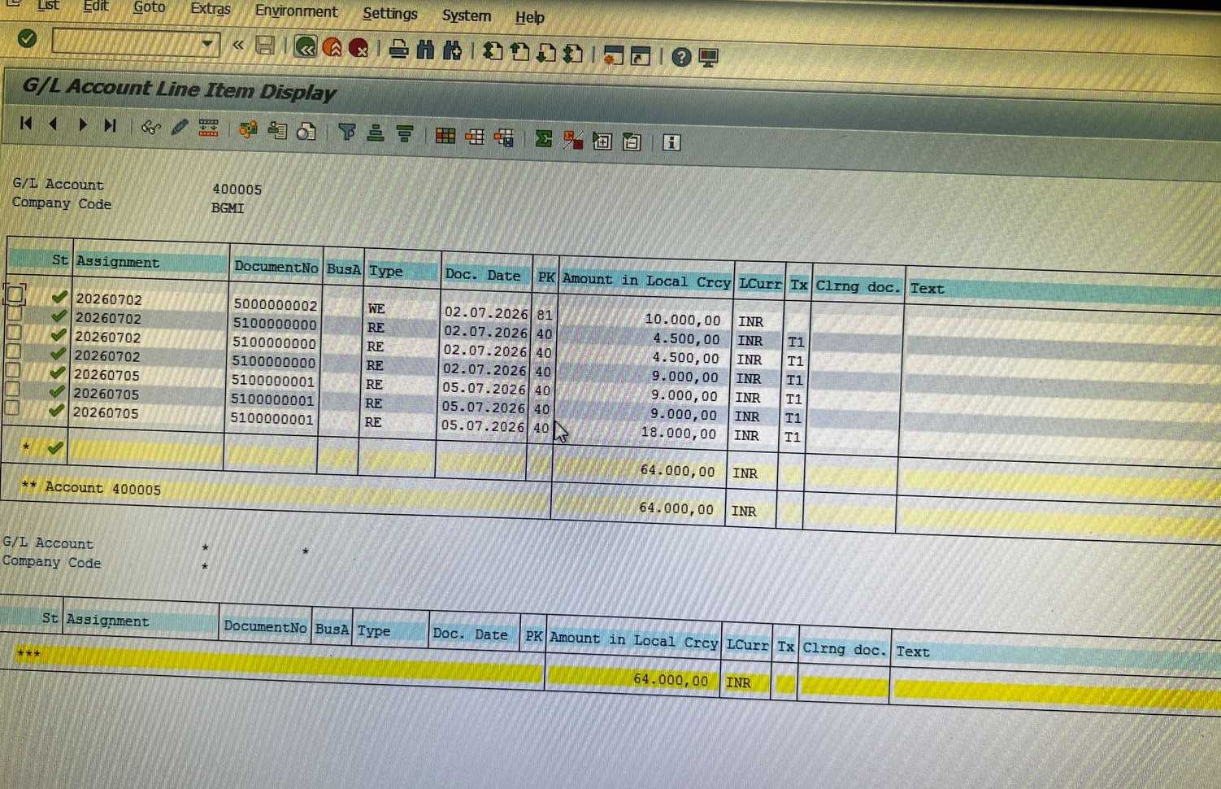
At MIGO: * Debit: Inventory / Consumption
Credit: GR/IR Account
At MIRO: * Debit: GR/IR Account
Credit: Vendor Account

Definition of TR (Transfer Request)
In the context of Warehouse Management (WM) within your MM flow:
Transfer Request (TR):
A Transfer Request is a document used to initiate the movement of goods within a warehouse. It serves as a preliminary signal to the Warehouse Management system that stock needs to be moved from an interim storage area (like the receiving dock) to a final storage bin. It tracks the quantity and material type but does not complete the physical movement until a Transfer Order (TO) is created.
MY TR IS (A4HK900571)- IN BGMI PVT LTD BASED IN INDORE CO CODE(BGMI)
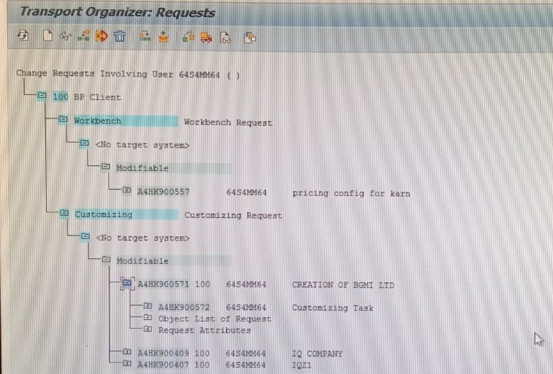
THINGS I HAVE IMPLEMENTED IN MY COMPANY FULL MM&FI INTEGRATION AND IMPLEMENTATION
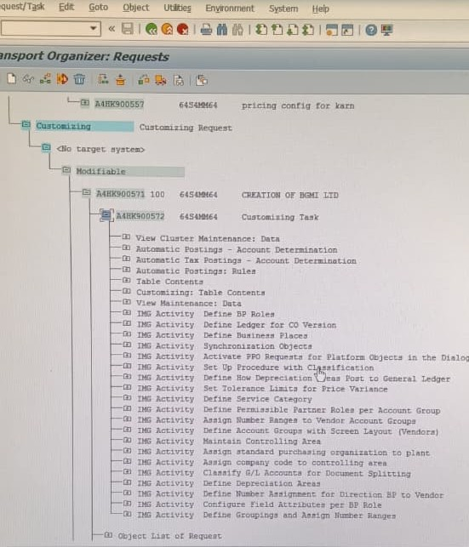

Project Overview: Full SAP MM Implementation
To finish your project, you can use this "Project Summary" section. This explains the scope of what you built.
Project Title: End-to-End Procurement & Inventory Management Implementation
1. Project Objective
The goal of this project was to implement the SAP MM Module to streamline the procurement cycle, automate inventory tracking, and ensure seamless integration with Financial Accounting (FI) for accurate reporting.
2. Implementation Scope
The implementation covered the complete Procure-to-Pay (PTP) cycle, including:
Master Data Management: Configuration of Material Master, Vendor Master, and Purchase Info Records.
Purchasing: Automation of internal requirements via Purchase Requisitions (PR) and external procurement via Purchase Orders (PO).
Inventory Management: Processing Goods Receipts (MIGO) and monitoring stock movements using movement types (e.g., 101 for GR).
Invoice Verification: Implementing a Three-Way Match (PO-GR-IR) to ensure financial compliance via MIRO.
Integration: Real-time posting of material documents to General Ledger (G/L) accounts, verified using FBL3N.
3. Business Benefits
Real-time Visibility: Enabled instant tracking of stock levels and procurement status.
Financial Accuracy: Automated the GR/IR clearing process, reducing manual errors in accounting.
Process Standardization: Standardized the purchasing flow across the organization, ensuring better vendor management and cost control.
Audit Readiness: Created a transparent "paper trail" from the initial request (PR) to the final payment, easily accessible through SAP standard reports.
4. Conclusion
This implementation demonstrates a robust procurement framework. By successfully linking the logistical flow (PR-PO-MIGO) with the financial flow (MIRO-FBL3N), the system provides a "single source of truth" for both warehouse managers and financial controllers.
A Little Tip for Your Project:
Since you mentioned FBL3N, you can add a small note saying: "Integration with FI was validated by checking the automatic credit/debit entries in the General Ledger, confirming that the MM and FI modules are working in sync.

MADE BY-KARN PRATAP SINGH RATHORE

